Assignment-2
Name:M.Harshith

Ht.no:2303A51444
Batch.No:21

Task-1:CleaningSensorDataPrompt used:
write a python code using functions to clean the sensor data ,valid dataofpositivenumbersandzeros,invaliddataofnegativenumbers. the list should be taken from the users. And also print list before cleaningandaftercleaning,alsothecodeshouldhandleedgecases.

Code:

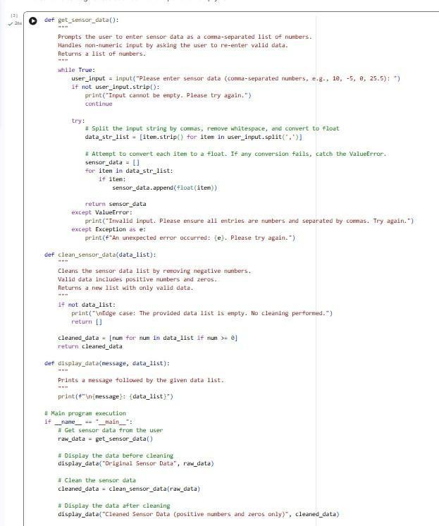

Output:
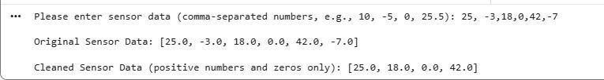
JUSTIFICATION:

Theprogram collects sensorreadingsfromtheuser with proper input validation to ensure only numeric values are accepted. The cleaning functionfiltersoutallnegativevalues,keepingonlyvalidsensordata(zero and positive numbers). Displaying the data before and after cleaningclearlyshowshowinvalidreadingsareremoved,makingthe data reliable for further processing.

Task-2:StringCharacterAnalysis

Promptused:
write a python code using functions that accepts string and counts vowels,consonantsanddigitsinastring.thestringistakenfromtheuser,the code should handle edge cases also.

Code:

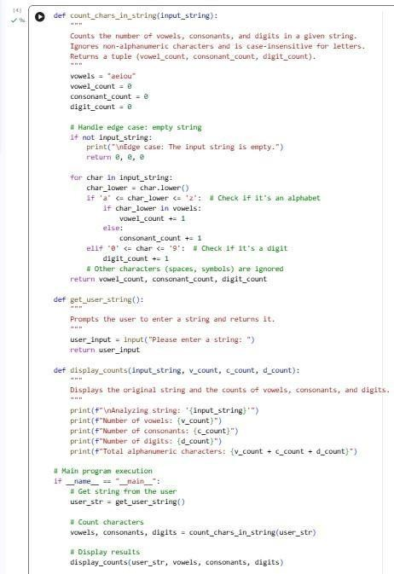
Output:
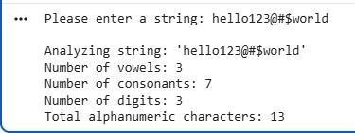
JUSTIFICATION:

Theprogramconvertseachcharactertolowercasebeforecheckingit againstthevowel list, makingthelogic case-insensitive. Becauseof this,bothcapitalandsmallvowels(A, E,I,O,Uanda,e,i,o,u)are counted correctlyusingasinglevowelset.Thisapproachsimplifiesthecode and avoids writing separate conditions for uppercase and lowercase letters.
Task3:PalindromeCheck–ToolComparisonGemini code:
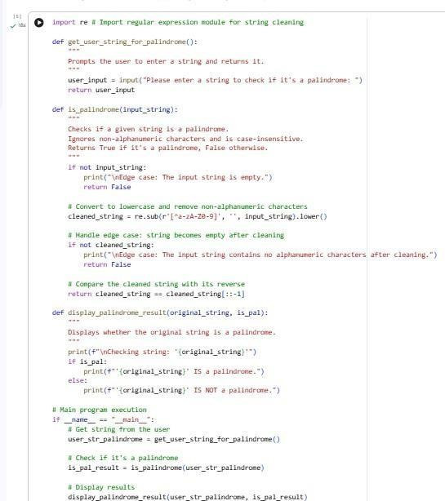
Output:

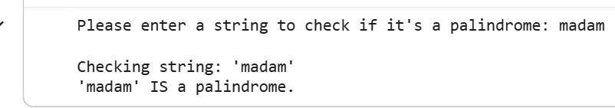
CopilotCode:
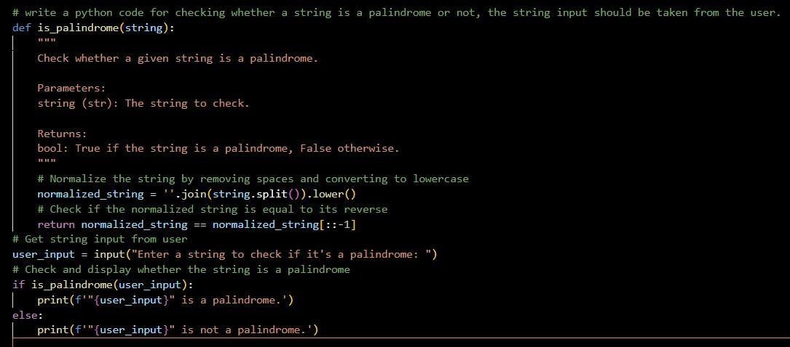
Output:
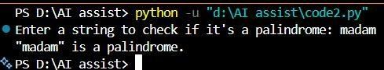
PromptusedforbothAI’s: writeapythoncodeforcheckingwhetherastringisapalindromeornot,the string input should be taken from the user.

- Side-by-SideCodeComparison Gemini-Generated Code
  - Usesmultiplefunctionsforinput,processing,andoutput.
  - Cleansthestringusingregularexpressions.
  - Handlesedgecaseslikeemptyinputandstringswithonly symbols.

  - Providesdescriptivemessagesduringexecution.
- Copilot-GeneratedCode
  - Usesasinglefunctionwithconciselogic.
  - Cleansthestringbyremovingspacesandconvertingto lowercase.
  - Focusesonlyonthecorepalindromecheck.
  - Minimalexplanationsandnoedge-casehandling.
- ObservationsonClarityandStructure
Aspect Gemini Copilot

Code structure Modular(multiple functions)
Readability Veryclearand descriptive
Simple(single function)
Compactbutless detailed

Edge-casehandling Yes No
Beginnersuitability High Medium

Useofadvanced concepts
Regularexpressions Basicstring
operations

MyExperienceonusingbothGeminiandCopilot:
Gemini provided clear, well-structured code with detailed explanations, which made the logic easy to understand. Copilot generated concise and efficient code but with minimal explanation. Overall,Geminiwasbetterforlearning,whileCopilotwasusefulforquick coding.
Task-4:CodeExplanationUsingAI Prompt used:

Explainpalindromecheckingcodeinpythonlinebylineusingsimpleand clear language for beginners .
Code:
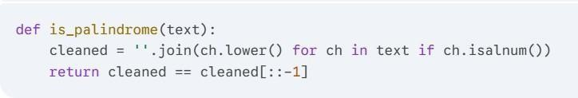
AIExplanation:
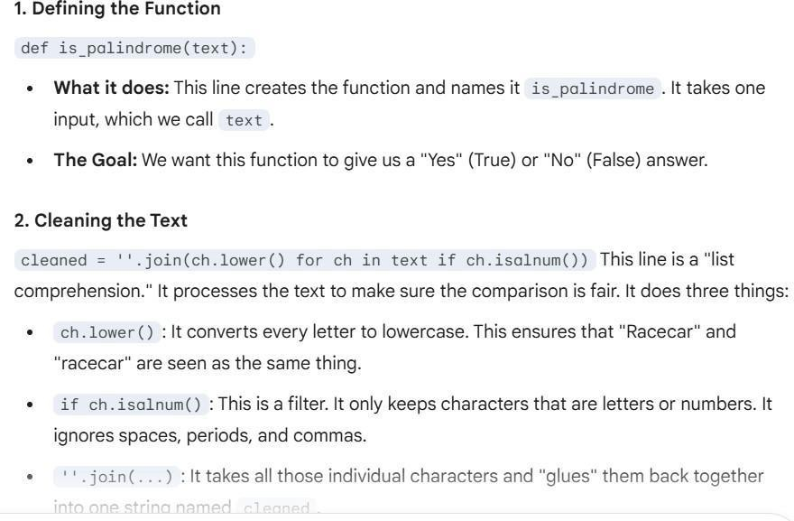

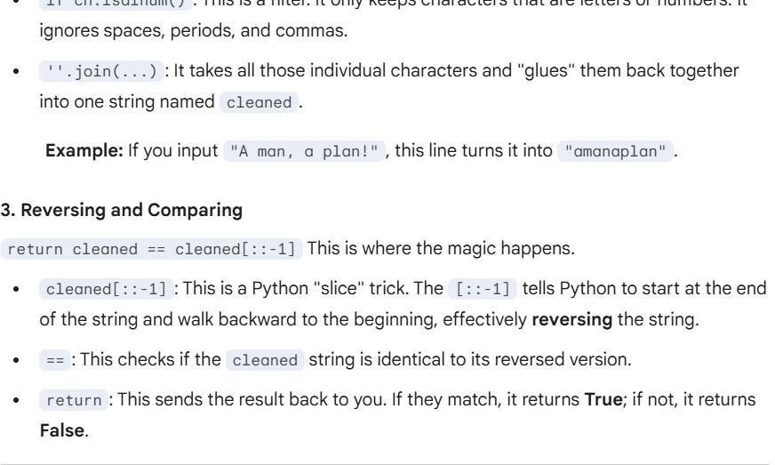

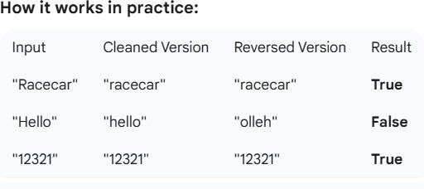
Studentcommentsonunderstanding:
From theAI explanation, I understood how the function first cleans the input string by converting all characters to lowercase and removing spaces and special symbols. This makes the palindrome checkaccurateandcase-insensitive.Ialsounderstoodhowreversing the stringusingslicinghelpscompareitwith theoriginalcleanedstring to decide whether it is a palindrome or not.

